**Personal Portfolio**

**(70)**

**(Shaleen Dutt – N9379126)**

**(**[**IFB299-Group-70-S.K.R.A.M**](https://github.com/rdugg4/IFB299-Group-70-S.K.R.A.M)**)**

**Artefact 1** **–** Redesigning webpages

### (Description about what the artefact is in general)

Originally webpages containing graphs were created by cs student, after reviewing these pages from a client perspective, design aspect needed to be changed. Further HTML and CSS was used to redesign graph webpages.

### (Brief description of how it was used/contribution to the project)

The redesigned pages made the look and feel match with other pages along with being more user friendly to the clinet. These redesigned webpages were used in the final product of the application with all the functioning aspects implementing by cs students.

### (Screen capture of where it’s used)

HTML and CSS code can be seen in the zipped files

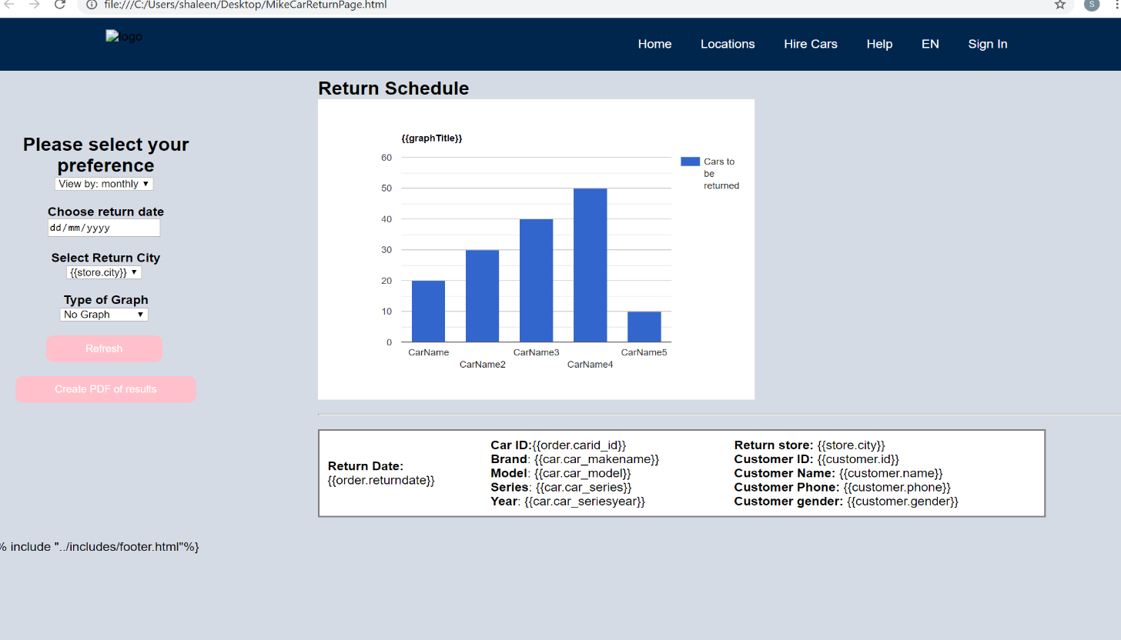Before:

After:

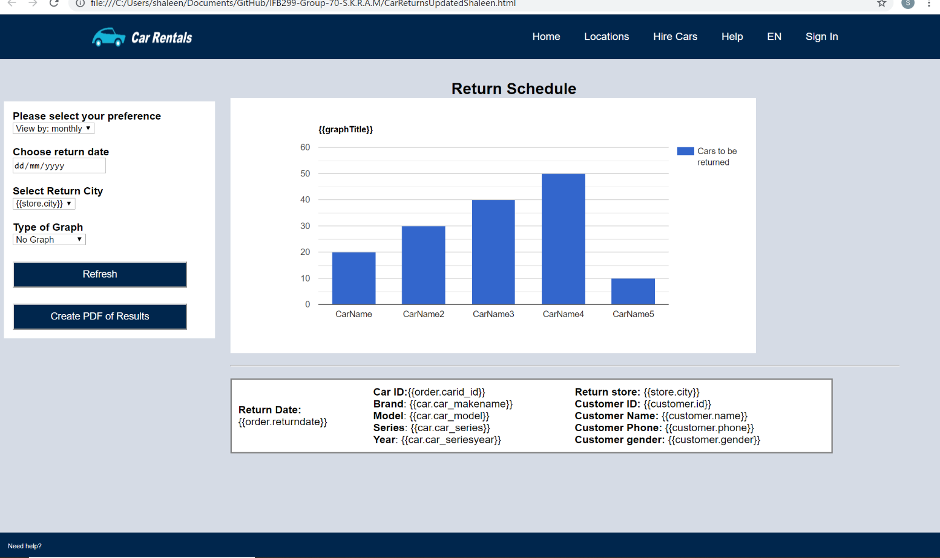

**Artefact 2 –** Design of FAQ Page (UI)

### (Description about what the artefact is in general)

Design of FAQ page in other words user interface design. The design was made based on the FAQ user story and backlog. The FAQ were from researching other car rental websites to see the most common questions customers have

### (Brief description of how it was used/contribution to the project)

The design was used to interpret user story acceptance criteria, to have a clear visualisation of the user story. The questions relate to the user story “as a customer, I want to know more information and guides about the rental services so that I can avoid misunderstanding and mistake”. Most relevantly this design was used as a clear visual guide when creating the webpage using HTML/CSS, regarding style, placing of elements on the page and colours.

### (Screen capture of where it’s used)

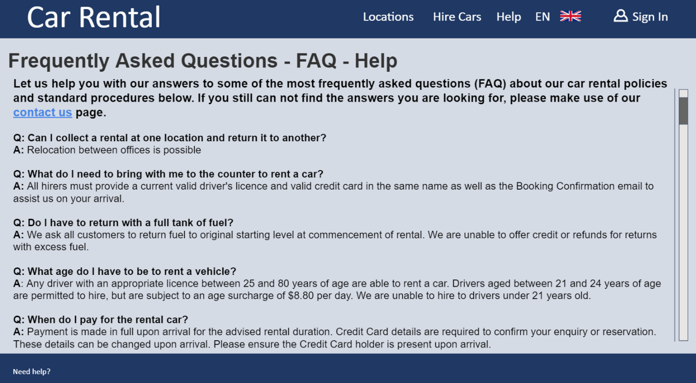

**Artefact 3** – Create customer account webpage (HTML/CSS)

### (Description about what the artefact is in general)

Physically creating FAQ webpage using HTML and CSS. Implementing, text and a link.

### (Brief description of how it was used/contribution to the project)

This page is used in our website to meet user requirements, so that customers can view FAQ before having to contact a store. Further once creating this page the CS students in the group took it and make the contact us link functional.

### (Screen capture of where it’s used)

HTML and CSS code can be seen in the zipped files

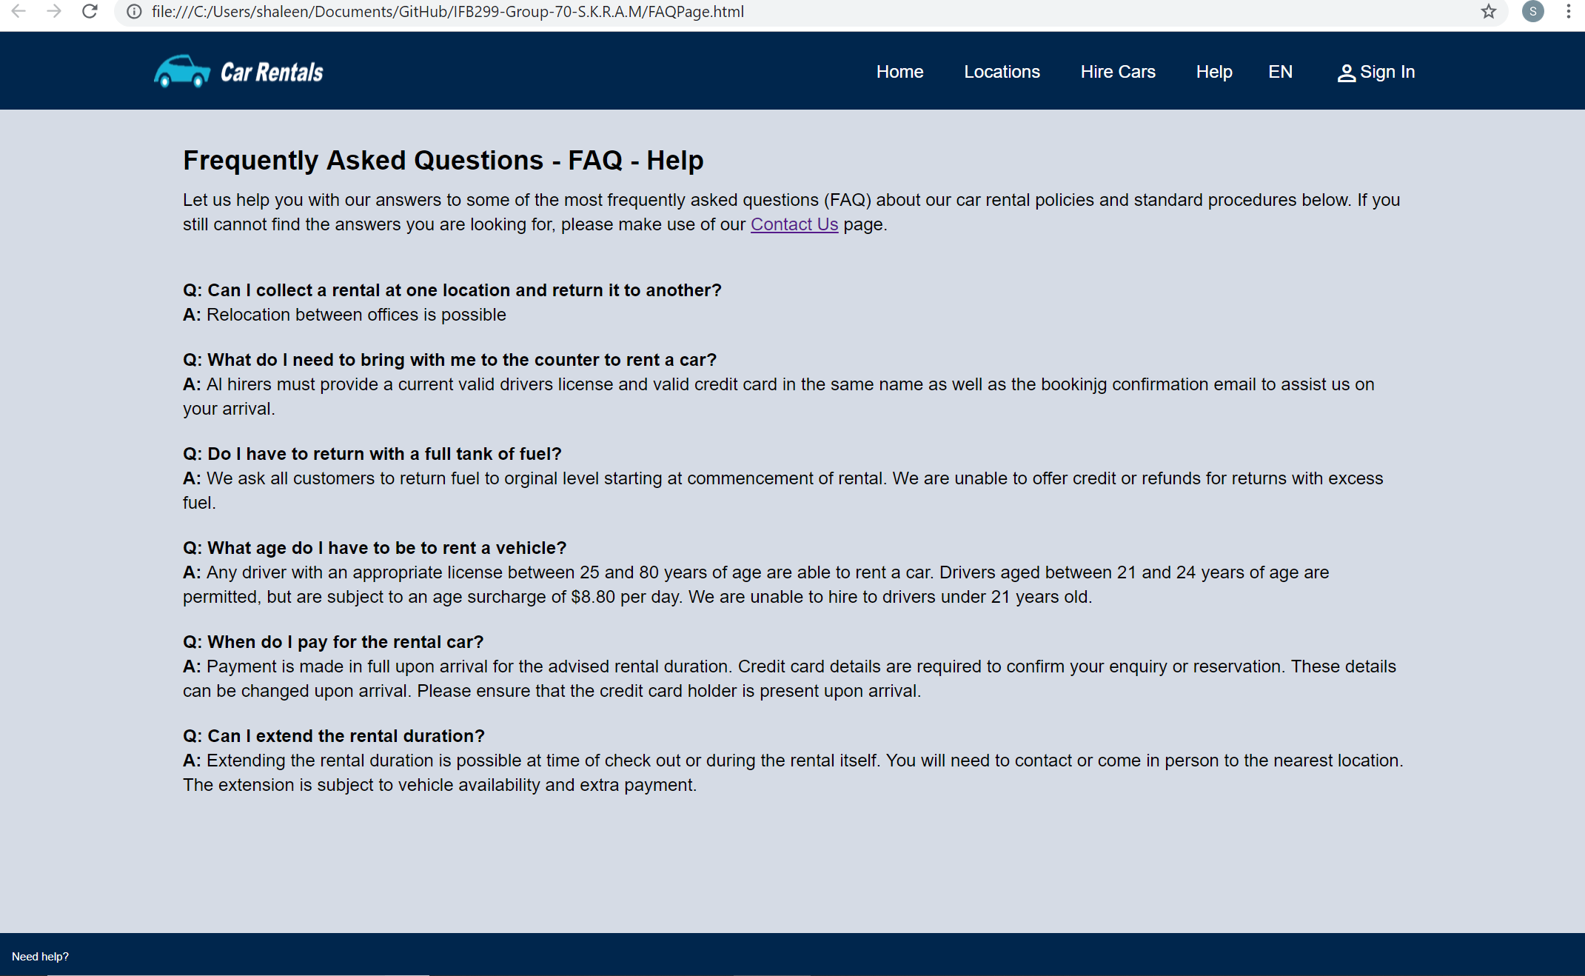

**Artefact 4** – Creating data sets for unit testing

### (Description about what the artefact is in general)

### Creating data sets to be able to test through unit testing. Created data sets based on cars from the database including (car model, series, year, price, engine size, fuel system, tank capacity, power, seating capacity, transmission, body type, drive and wheel base.

### 

### (Brief description of how it was used/contribution to the project)

These data sets were created to so that CS students cause implement these in unit testing to be able to verify the application is working as it should be with no errors along with testing the databases. These unit tests were also used to ensure that user stories and backlog requirements are met.

### (Screen capture of where it’s used)

Screenshot of 6 data sets are included, all 20 data sets can be seen in the zipped flies

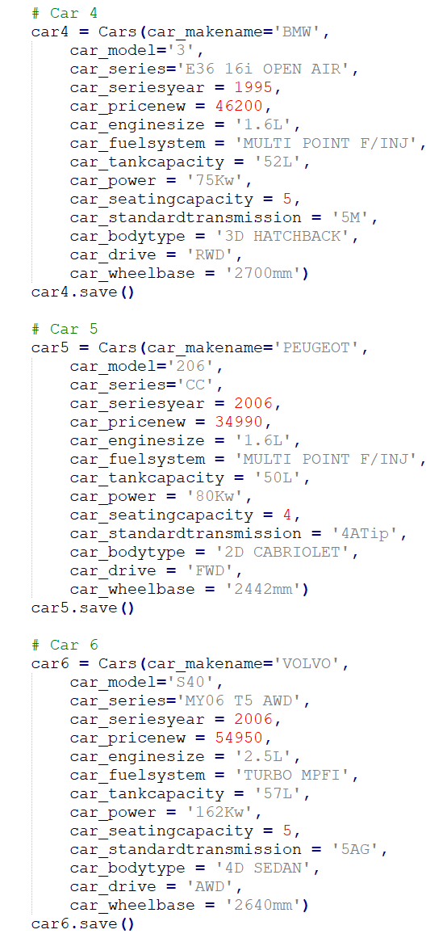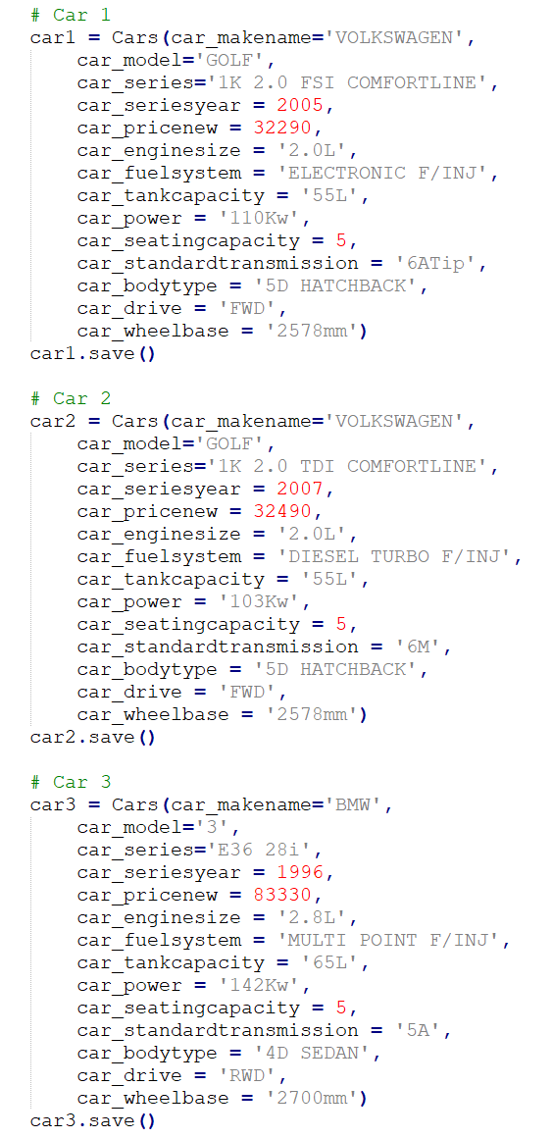

**Artefact 5** – Verify User Stories are complete (Car Recommendations)

### (Description about what the artefact is in general)

Verifying if stories are completed against user stories/backlog. This is done through individual webpages and checking if the webpage is matching user story and backlog criteria.

### (Brief description of how it was used/contribution to the project)

Verification of stories are used to make sure that the final webpages are functioning correctly and contain all elements specified by user requirements and the backlog. Along with webpage verification of overall technical and design standards are met. Verifying these stories allowed for changes to be made whether it was technical or design based.

### (Screen capture of where it’s used)

|  |  |  |  |
| --- | --- | --- | --- |
| **Backlog** | **Completed/ Not completed** | **User Story** | **Completed/ Not completed** |
| Add a search criteria called recommended cars | Completed | The list should show no more than 5 sorted results | Completed but shows more than 5 cars |
| Recommends cars based on the information in the customer’s profile | Completed | The recommendation should be based on geography (customer’s picking address) information and time (Month). | Completed |
| Display cars the same way as when a car search is made | Completed | Some of the car information should be shown, consisting of Price, type, brand, Engine Size. | Completed |